**creation of group ,add IAM user in that group and attached administrator policy to it.**

**Iam.tf**

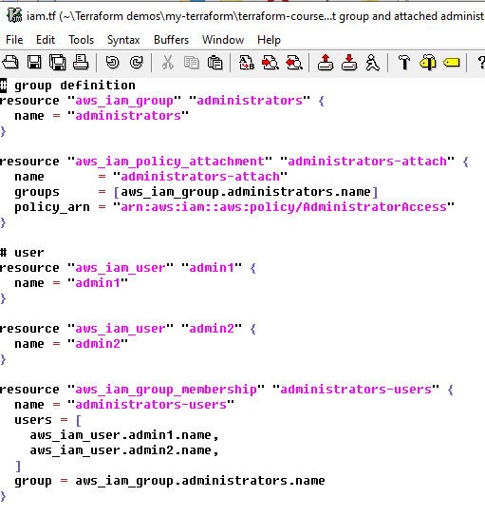

**Terraform.tfvars**

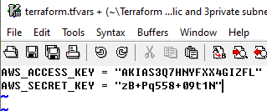

**Provider.tf**

